**Mission 2:**

**Introducing CodeX**

**Student Workbook**



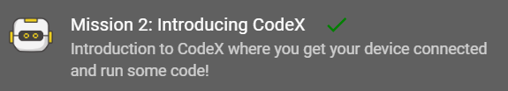

**Greetings!**

You are at the beginning of an exciting journey. I’ll be your guide as you explore coding with your CodeX, using Python.

Why should you learn coding?

* It is more than robots
* It is more than computers
* It is more than laptops or tablets
* It is more than cell phones
* It is more than games

Computer chips are making lots of things we use smarter.

But … everything a computer does is coded by people like YOU.

Go to the Mission 2 Log and fill out the Pre-Mission preparation.

**Mission 2: Introducing CodeX**

* Go to <https://make.firialabs.com/> and log in.



* Click and start your coding journey with Mission 2.

**Objective #1: Behold the CodeX**

What is CodeX?

It is a powerful embedded computer.

That means it has a lot of stuff on that little circuit board.

It has: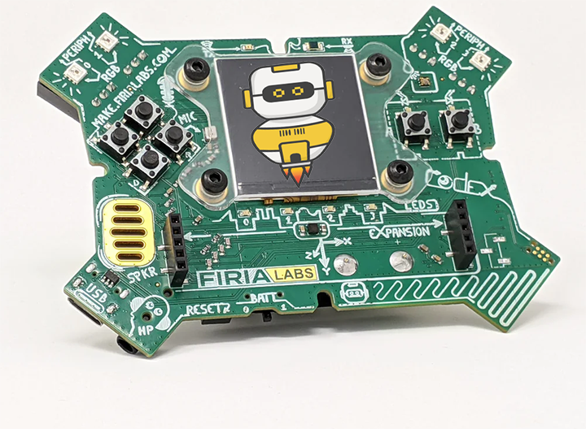

* Lots of sensors
* Bright, colorful lights
* A speaker
* Buttons to press
* A colorful screen
* And more!

**DO THIS:**

The instruction panel has 3 words that can be added to the toolbox.

Click on at least one of these words.

* Fill out Objective #1 in the Mission Log

**Objective #2: Static Electricity**

Be careful with your CodeX.

* Static electricity ⚡can build up inside you when you walk across a carpet, or other similar things.
* Static electricity ⚡ causes a shock when you touch something.
* It can shock the CodeX if you touch it.
* This is not good for CodeX!

Follow these guidelines to keep your CodeX static-free

* Hold CodeX by its edges
* Be gentle
* Keep CodeX in its case when you are not using it
* Touch a desk or book before using CodeX

**DO THIS:**

Use the simulator to look for three lightning bolts ⚡on the CodeX.

* Close the instruction panel
* Use camera controls to rotate the CodeX in the scene
* Find all three ⚡and click on them
* One is on the back, so make sure you rotate   
   all the way around



**Mission Quiz**

Test your skills by **taking the quiz**.

**Objective #3: Find the CPU**

Where does the code run? On the CPU. The CPU is an amazing device! The CPU is:

* Central Processing Unit
* The “brain” of CodeX
* Interacts with other computer parts (called peripherals)
  + 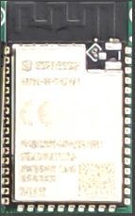Lights
  + Screen
  + Speaker

CPU has many responsibilities:

* Collects data
* Issues commands
* Pushes display information
* Stores information
* And many more things

**DO THIS:**

* Click on to add it to your toolbox
* Write about the CPU in the Mission Log
* Close the instruction panel
* Use the camera controls to rotate the CodeX and find the CPU
* Click on the CPU

**Objective #4: Connect the USB**

A USB cable is used to connect CodeX to your computer or laptop.

* The USB cable lets your computer communicate with the CodeX.
* It provides 5 volt DC power to the CodeX.

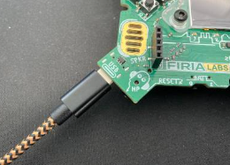

**DO THIS:**

* Close the instruction panel
* Use the camera controls to rotate the CodeX and find the USB port
* Click on the port

**Objective #5: Link to CodeSpace**

The CodeX must be linked to your browser before it can be used with CodeSpace.

**DO THIS:**

* Gently take out your CodeX
* Connect the CodeX to your computer with a USB cable
* Close the pop-up window
* Click on the red message at the bottom of the window

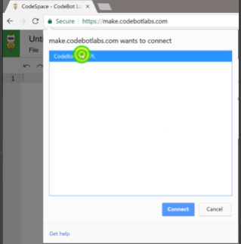

* + - * Select CodeX from the pop-up window
      * Click the 
      * Notice that the message now says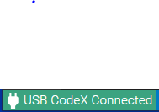

**Objective #6: Save the Code**

Time to create a file!

* When you type code into the **text editor** panel, it is automatically saved in the CodeSpace cloud!
* Your code is stored in a file
* You give the file a name, which should help you know what the code does

Create a new file for each mission.

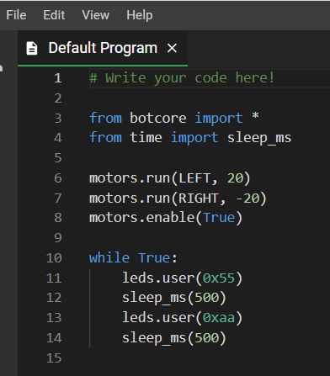

**DO THIS:**

* Click the **File** menu button
* Select “New File…”
* Name the file **Heart1**
  + *no spaces in a file name*
* Click **Create**

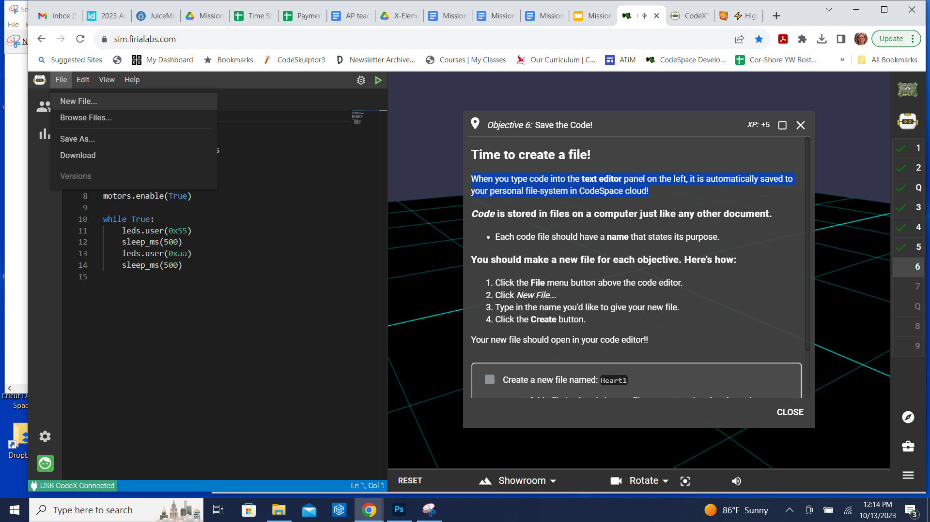

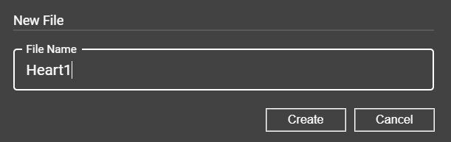

**Objective #7: The CodeTrek**

The CodeTrek icon is at the bottom of the instruction panel.

The CodeTrek is a **CodeSpace** tool that gives you:

* A starting point for your program.
* Information about lines of code you need to write.
* Explanations of coding topics.
* Program holes (**#TODOs**) for you to fill in.

**# TODO** -- The words “to do” put together

* A tells you what you need to do to complete the program.
* It tells you there is still work **TO DO**!!
* If you haven’t typed in code where there is a then you haven’t completed the mission.

Check out CodeTrek

**DO THIS:**

* Click on the CodeTrek icon at the bottom of the instruction panel
* Read both messages
* Close the CodeTrek

**Mission Quiz**

Test your skills by **taking the quiz**.

**Objective #8: Show Some Heart!**

Important programming notes:

* Your code is case sensitive
* That means
  + lower-case needs to be lower-case
  + upper-case needs to be upper-case
* Punctuation is important
  + Indenting matters
  + Use a period . when needed
  + Match parenthesis ( )
  + Use a colon : where needed

**DO THIS:**

**Time to type!**

* Make sure your **Heart1** file has no code
* Click the icon to open CodeTrek
* Type the two lines of code EXACTLY as you see it
* 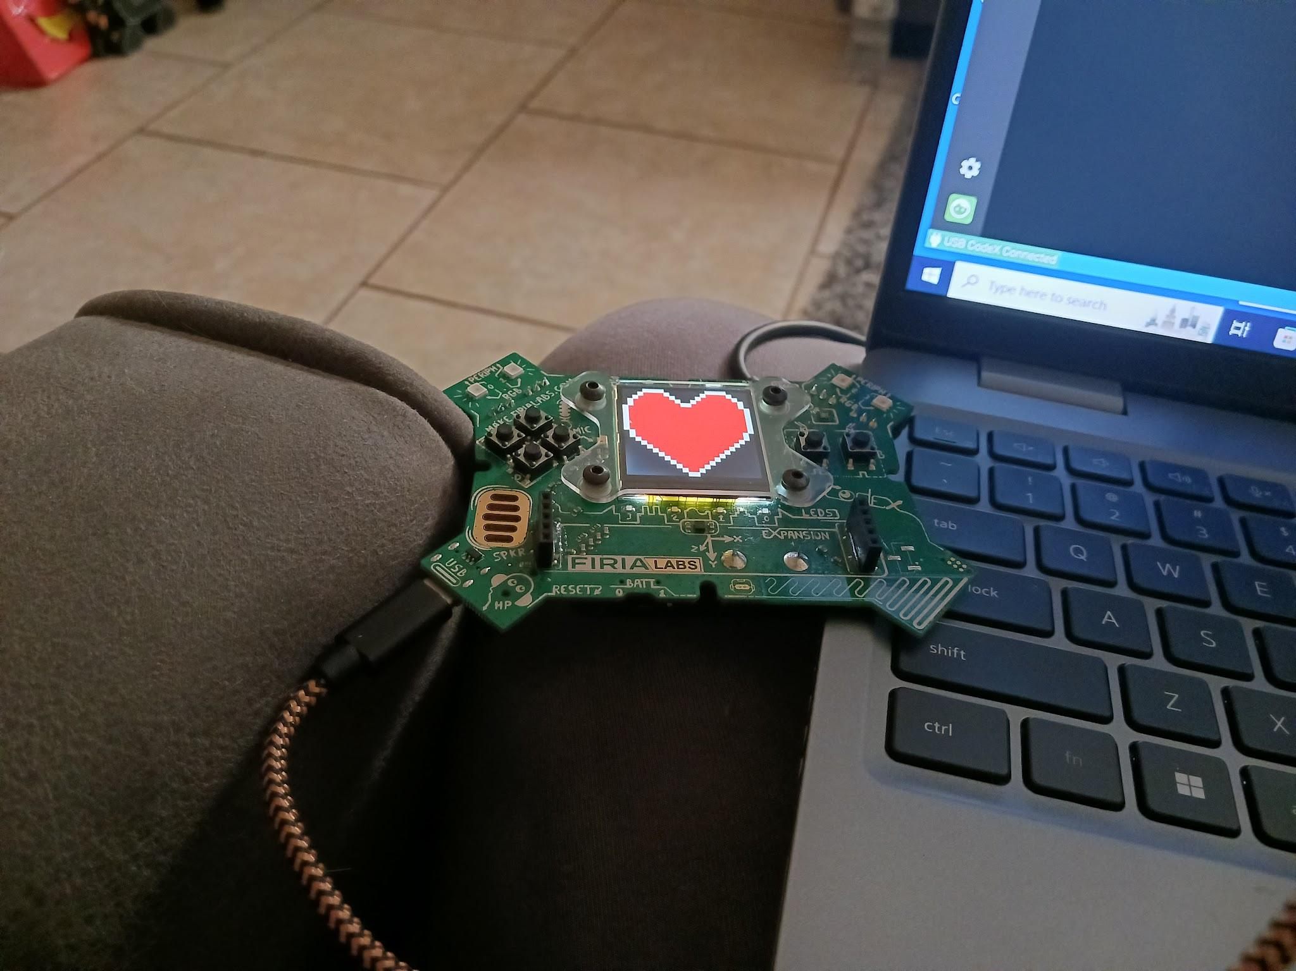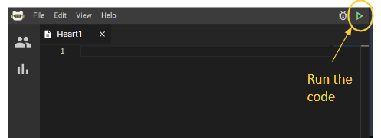Run the code

**Objective #9: More Images**

* The CodeX comes with more than one image ready for you to display. Find the images that are built-in.
* Click on
* Then scroll down in the toolbox until you find the list of images
* Find out what images you can use

**DO THIS:**

* Go to the Mission Log and write down three images that interest you.
* Go to your **Heart1** file.
* Change the image from **HEART** to **MUSIC**
  + Use CodeTrek if you need help
* Run the code.
* 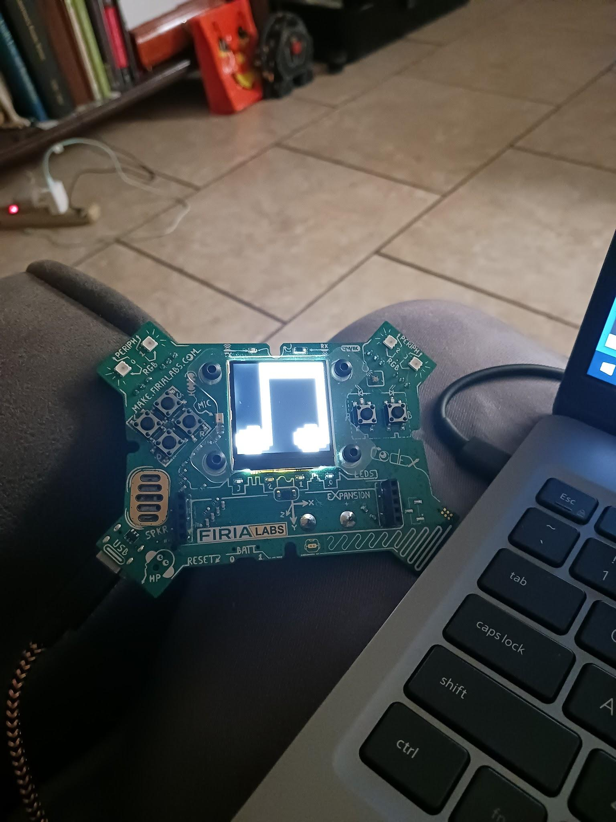Change the code to display another image.
  + Repeat for as many images as you   
     want
* Run the code after every change

Objective #9 is complete!

**Mission Complete**

You have completed the second mission. 

**Do this:**

* Read your “Completed Mission” message
* Complete your Mission 2 Log
  + Post-Mission Reflection
* 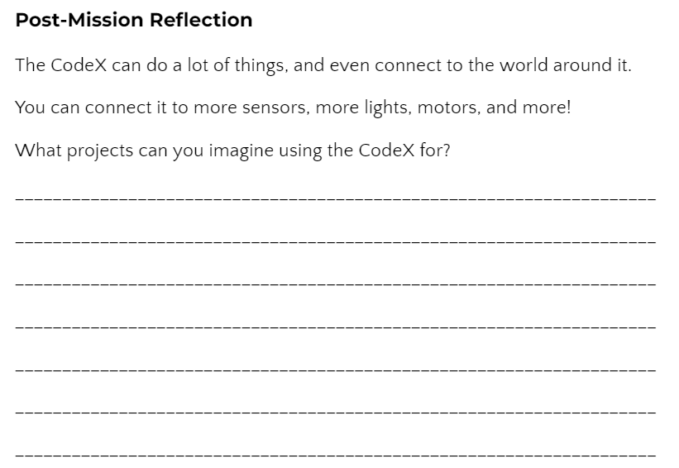Get ready for your next mission!